**Smart Water Management Using IBM Watson Platform**

* **INTRODUCTION**

**Overview:**

* Internet of Things (IoT) has taken the world by storm since its conception. The idea of connecting everything by wireless technology sums up IoT. We can connect anything using the sensors designed specifically for objects.
* IoT is the network of objects, devices, automobiles, houses and other items embedded with electronic sensors, and connectivity to enable them to talk to each other and execute functions.
* This work focuses on a solution for ‘Water management’ with the help of IoT. Water is precious and the supply needs to be regulated. Water demand is exponentially growing high with the increase in population.
* To maintain the supply demand ration proper, It is important to have systems to prevent any water loss & hence we have designed an IOT system with we can plan usage of water according to the availability.

**Purpose:**

* This project helps to regulate the proper maintenance of water tank, flow rate information to monitoring section with proper updation of records and the problem affects various processes in water management, such as water consumption, distribution**,** billing etc.

**LITERATURE SURVEY**

* Design of a Water Environment Monitoring System Based on Wireless Sensor Networks:

##### This paper is devoted to the explanation and illustration of our new design of water environment monitoring system, based on a wireless sensor network.

##### The system generally includes three parts: hardware and software of data monitoring nodes, hardware and software of the data base station, and software for the remote monitoring centre.

##### Smart Water Management is mainly concentrating in reducing the challenges facing in the water sector.

# Smart Water Monitoring System Using Wireless Sensor Network at Home/Office:

* This paper is about developing an efficient wireless sensor (WSN) based on water monitoring system.
* There are two different ways to monitor the water: water level monitoring and water pipeline leakage monitoring. Finally, this is water monitoring system of smart homes/office research concept will be completed by using wireless sensor technology.
* By using the monitoring system, we can find a more optimal way to preserve the water, hence saving it for the present and the future generations.

# Water Quality Monitoring System Using IBM Cloud and Watson IoT platform for Wireless Sensor Network:

* Here, we are using IBM cloud for tank level and flow rate monitoring system offering low power consumption with high reliability is presented.
* An important fact of this system is the easy installation of the system, where the base station can be placed at the local residence, close to the target area.
* The monitoring task can be done by any person with minimal training at the beginning of the system installation.

# PROPOSED SYSTEM:

* In accordance with the literature survey, we are trying to make a smart system for controlling the wastage of water by using an ultrasonic sensor to sense the level of water in tank.
* If the water tank is full or up to the maximum level the sensor will sense it and stop the system automatically. If the water tank is at the minimum level set by user, the sensor will sense it, activate the motor pump and stop at the maximum level. We can control this whole process using IOT.
* Our project is mainly classified into different phases. They are:
* Water level detection using ultrasonic sensor.
* Based on sensor value motor is controlled using relay module and also can be controlled by the user.
* Uploading sensor values to cloud platform via ESP8266 module.
* Alerts are sent when ever motor is ON/OFF. And user can give alerts to the authorized person when ever water is supplied to the house in specific areas by SMS.
* User can also remote controlling of the water supply from the main tank to individuals.
* User can calculate the amount of water usage in a certain period of time and area.

**THEORITICAL ANALYSIS**

* **BLOCK DIAGRAM**

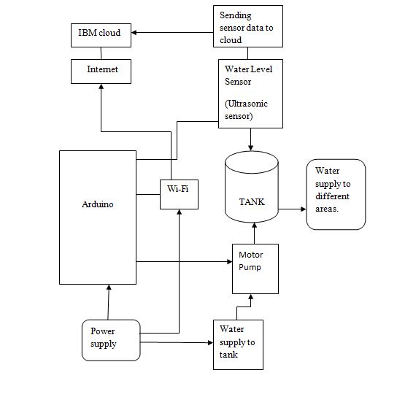

* **HARDWARE**
* **Arduino UNO Board**

The hardware consists of an Arduino microcontroller development board, Ultrasonic Sensors and a Wi-Fi module to collect & transfer data to cloud. Data is collected from ultrasonic sensors using Arduino Uno microcontroller. Arduino is an open source hardware platform which is compatible with various sensors and communication technology. There are different types of Arduino microcontroller that are used for different purposes. It not only control devices but also can read data from all types of sensor. Arduino Uno is a microcontroller board based on the ATmega328P. It is simple, low cost, easy to use and easily available in the market. It takes 5V voltage as input at the speed of 16 MHz. Arduino Uno contains 14 digital input /output pins and 6 analog input pins to connect various sensors that gives analog inputs.



* **ESP8266-WiFi Module**

The ESP8266 Wi-Fi Module is a self-contained SOC with integrated TCP/IP protocol stack that can give any microcontroller access to the Wi-Fi network. The ESP8266 is capable of either hosting an application or offloading all Wi-Fi networking functions from another application processor. Each ESP8266 module comes pre-programmed with an AT command set firmware, which means, one can simply hook this up to Arduino device and get about as much Wi-Fi-ability as a Wi-Fi Shield offers. This module has a powerful enough on-board processing and storage capability that allows it to be integrated with the sensors and other application specific devices through its GPIOs with minimal development up-front and minimal loading during runtime.



* **Ultrasonic Sensor**

An Ultrasonic sensor is a device that can measure the distance to the target (water level) using sound waves. It measures the distance by sending the sound waves at a specific frequency and then listening for it to bounce back. This helps keep track of the current level of water between maximum water level and minimum water level as set by the user.



* **Motor Pump**

Motor Pump is used to move water into the tank. The Motor Pump is connected to the Ultrasonic sensor via the embedded system. When the Ultrasonic sensor detects water level between the lower range and the upper range. It can be operated manually or Remote controlling through app.



* **RTC module**

**RTC** means **Real Time Clock**. RTC modules are simply TIME and DATE remembering systems which have battery setup which in the absence of external power keeps the module running. This keeps the TIME and DATE up to date. So we can have accurate TIME and DATE from RTC module whenever we want.

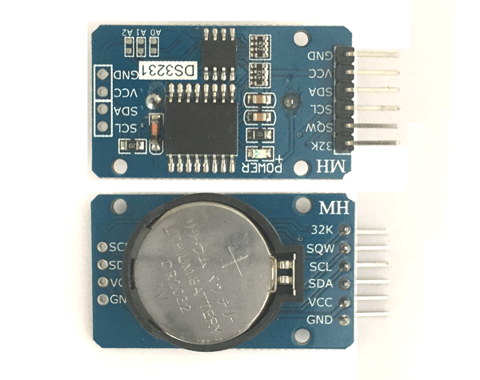

* **SOFTWARE DESINGING**

### Create the Web UI to visualize the Tank level, Flow rates , billings and control parameters

* Create a IBM account and in that create node red, cloudant, Watson IoT platform .
* After creating the above services go to IBM cloud dashboard, click on Cloud Foundary apps
* A new window appears where we need to NODE-RED app created before.
* After opening the node red service, take the nodes which are required for representing tank level, flow rates buttons, debug nodes, function nodes etc.
* Connect the nodes to IBM IoT nodes to get the values to tank level, flow rates nodes etc.

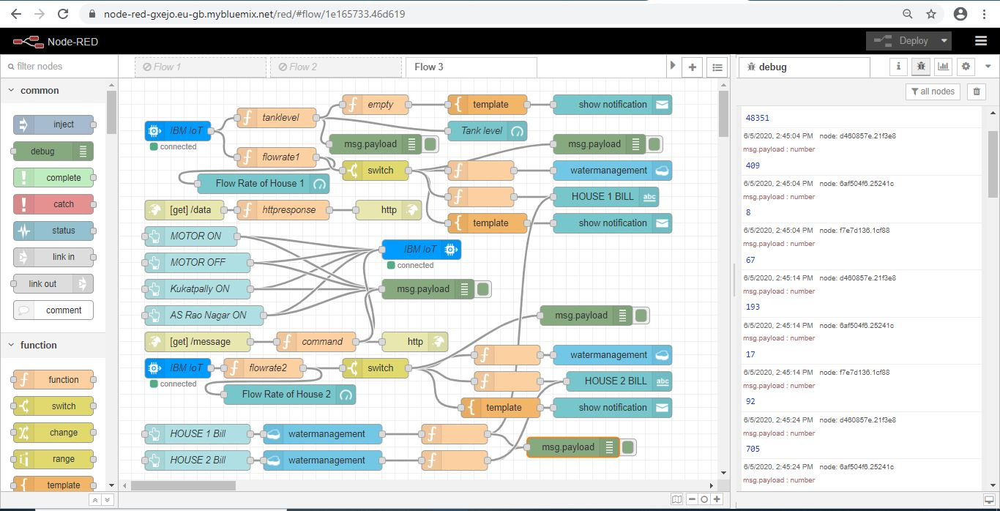

* After connecting all the nodes , Copy the Node Red URL till .net and paste in the new tab by typing /ui along with the Node Red URL and press ENTER which will display the UI.

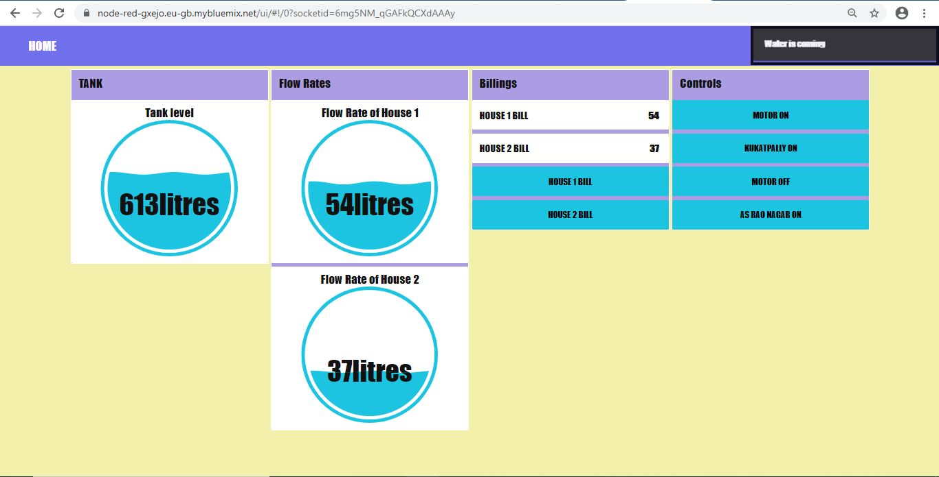

* Copy the URL in the Node Red flow till .net and paste in the new tab by appending “/data” along with the URL and press Enter. Both the tank level and flow rate values will be displayed on the webpage

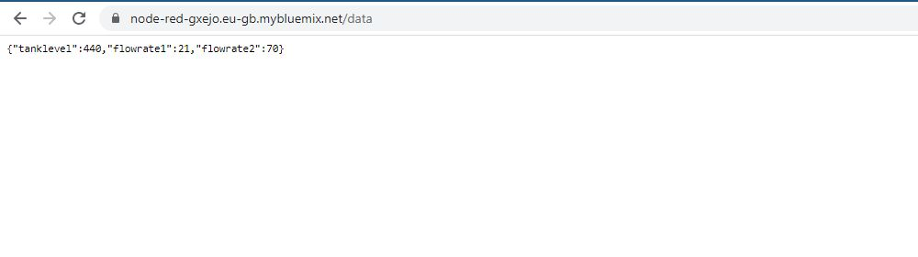

* As the values are sent to cloudant with the given file name.

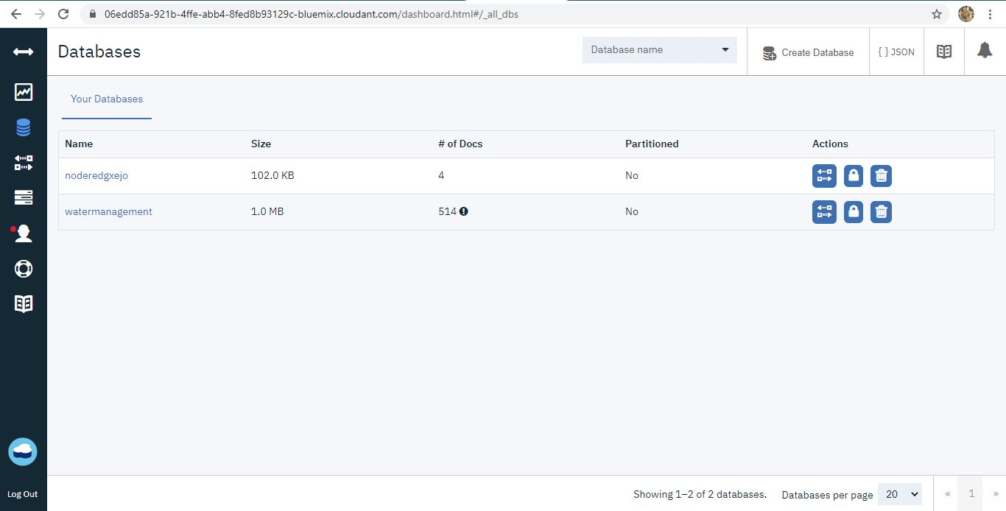

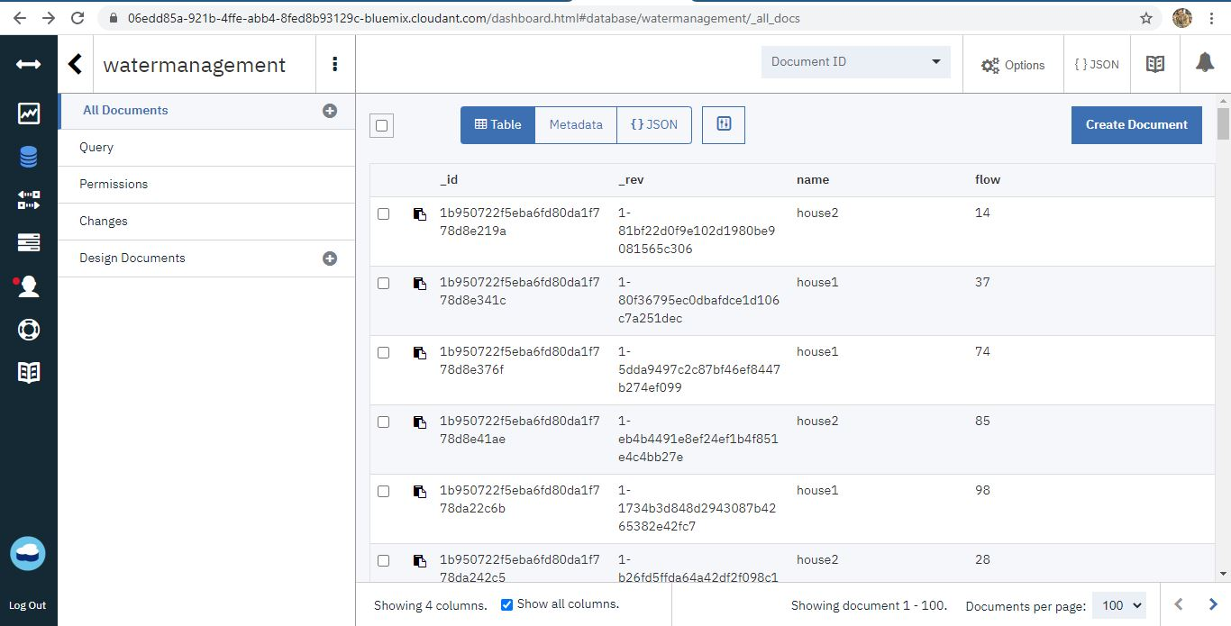

* The data is stored in the json format.

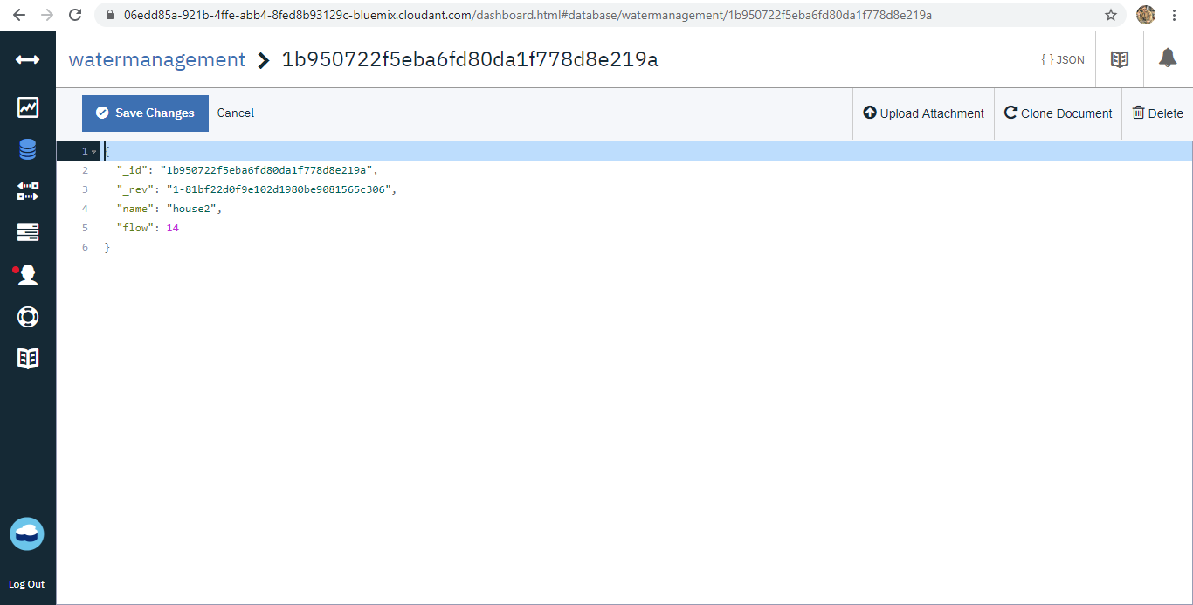

* **Create a mobile application visualizing the sensor reading and buttons to control the motor , bills, alerts etc.**
* MIT App login
* Type MIT App inventor in google search and press Enter, select the first link in the search engine
* Click on the first link you will be redirected to MIT App Inventor dashboard.
* Click on Create Apps! It will redirect to the Gmail login page. Through Gmail account by typing your Username and Password, you can log in to the MIT App flow editor.
* Agree with terms and conditions.
* By agreeing with the terms and conditions you will be redirected to the Dashboard and click on Start new project.

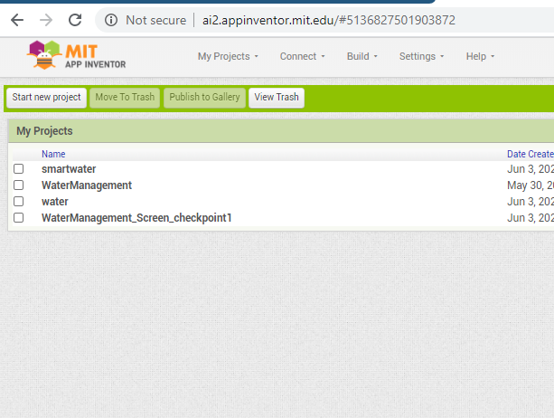

* Displaying the tank level and flow rate values and controlling the motor ON/OFF ,alerts for areas using the Mobile app

1. Create a UI to display the tank level and flow rate value in the Mobile App

2. Drag and Place two horizontal Arrangement in the mobile UI from the layout which is present in the palette

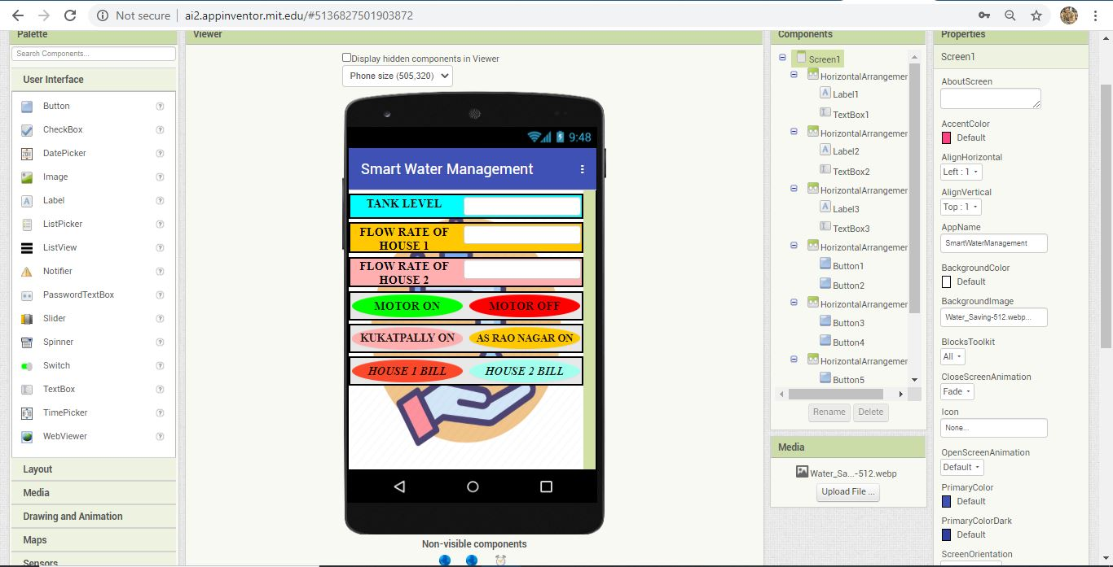

* After designing the screen go to blocks and design the blocks to

display the tank level and flow rate values.

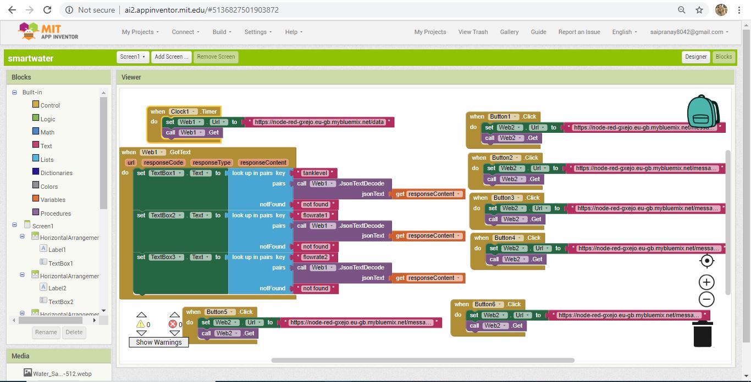

* After designing the blocks, go to build option to download the app through QR code.

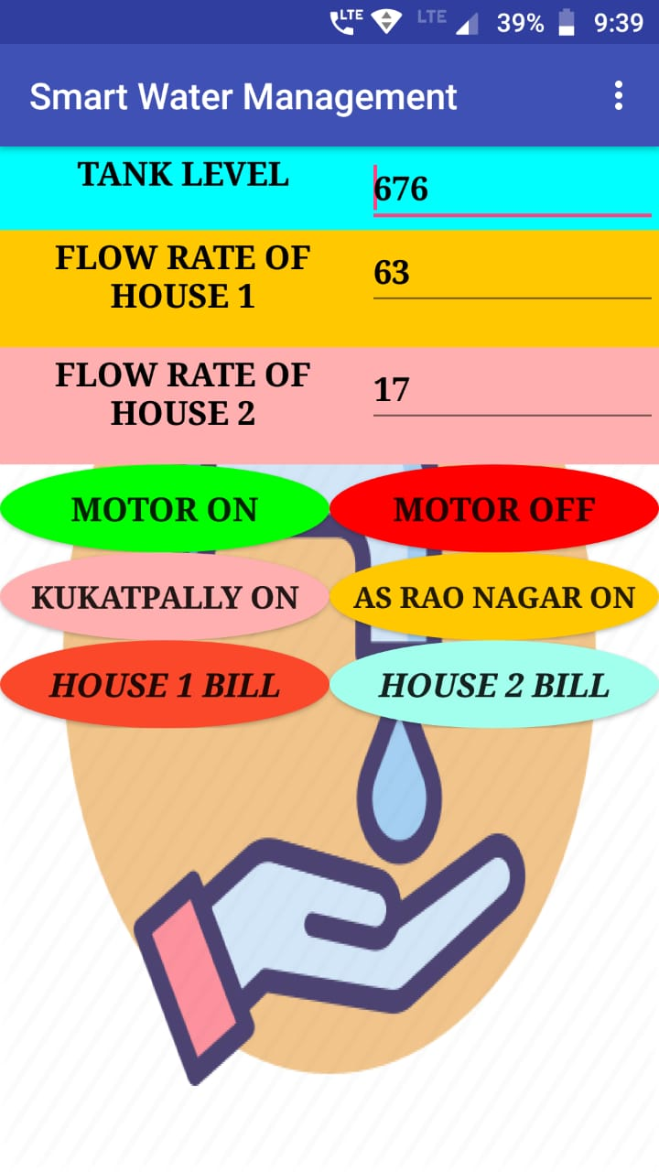

* From the above picture we can see that there are 6 buttons in which first two are for motor controlling, next two are for area wise controlling and last two buttons are for billing purpose.
* **Alert System**

**SMS Alert** : SMS alert system is implemented in such a way that SMS will be triggered when tank is empty and also SMS will be triggered to corresponding areas when the area buttons are pressed ,then SMS is sent to the concerned persons in that specific areas. And also alert is sent when ever level of water in tank goes below a threshold set the user.

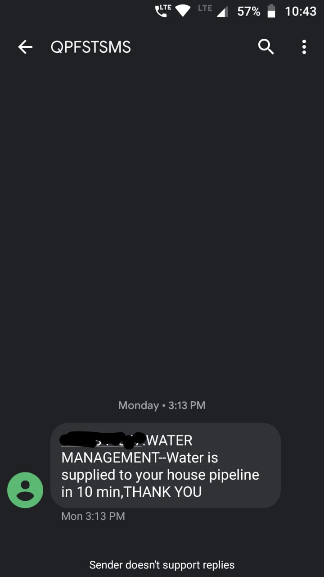

**FLOWCHART**



**RESULT:-**

* Water conservation is one of the essential aspects in water management, specifically in urban areas, where keeping a record of water consumption is extremely challenging. This issue can be solved using IoT which will keep a record of people using water on a particular day. We can analyze the data and the weather condition of that day to determine the amount of water consumed by the people on a particular city. This will surely help the water authorities manage the flow of water in much more effective manner.
* The IoT smart water management techniques can reduce water cost by up to 20 percent, resulting in better revenues with lower costs. [**IoT smart water**](http://www.biz4intellia.com/blog/iot-smart-water-a-big-technological-splash/) management system also provides opportunities to municipalities to reduce operational costs around construction, maintenance, and more.
* **Through IoT sensors, not only can we conserve valuable resources but also meet demands of the people adequately and make our lives convenient**. Most of the companies have already adopted IoT based services after knowing the issues related to water management.

# ADVANTAGES:-

Internet of Things and related systems bring about different advantages to the elements present in the industry. In short, it provides a new way that can help in collecting data, keep a check and problem-solving. It is one of the most exciting time for Internet of Things to get into action. It has created new ways for other elements to stay active in different industries.

* Power Saver
* Money Saver
* Automatic
* Water Maximization
* Easy Installation

# The three pillars of Smart Water Networks:

* Information: making full use of all data produced by a water utility
* Integration: utilizing current IT systems to maximize previous investments
* Innovation: having the flexibility to meet future challenges

# ****Real-Time Data Integration****

* There are basic levels of Smart Water Network integration that will provide utilities with almost immediate benefits.
* One specific capability that can quickly pay dividends is transforming real-time data into valuable information for faster decision-making in areas of the utility outside of the control room.

# ****DISADVATAGES:-****

* The primary **disadvantage** associated with a **smart** water is expense. These systems can be quite costly for specific equipments
* Water level controls need to be replaced every 3 years.
* The rust, foul and deteriorate
* Electronics are usually built separately
* More difficult installation for special equipments and special monitorings
* Most float switches are outdated
* No Warranty or Guarantee

**Applications in Smart Water Management**

* There’re plenty of smart water solutions that demonstrate how IoT and big data technology can improve the processes in the water industry.
* **Water system integrity**
* [Sensative](https://sensative.com/strips/drip/)strips are sensor-based leak detectors that help identify pipe or connection damage immediately and prevent heavy leakage and waste of water resources.

# These strips are incredibly simple to install and use both indoor and outdoor and therefore are great for households, offices and public places.

# Smart water monitoring

# It provides a wide range of water management services from leakage detectors to management.

# It is focused on smart water measurement and quality monitoring for different businesses in the supply chain — farmers, meteorologists, utility services, etc. The solution includes sensors, stations, telemetry units and software which processes generated data and creates insights for the decision-makers.

# ****More efficient handling of operations:****

* By providing some real-time operations, organizations can make use of real-time data and make smarter decisions. The real-time data obtained will help authorities and concerned individuals make smart and concrete decisions. Also, these real-time data obtained from sensors and less human intervention help smart systems to improve your water management practices.
* **More concrete efficiency and productivity:**
* IoT helps users determine the real-time data and provides information to make smarter and more intelligent decisions for your home and business. Also, these predictive maintenance features help to provide predictions about failures that might occur in the future. You can further use these patterns to fix risks in an instant. Finally, the output is more productivity and more efficiency of the system.
* **Higher revenue generation:**
* The Real-time monitoring feature of all devices that help you in reducing the entire management costs. These devices reduce maintenance costs to a greater extent. Also, it helps save energy costs, improves operations and processes, lowers infrastructure cost and requires less or no human intervention. Apart from that, one of the major costs that get consumed in the mobility of water that involves moving water from one place to the other. Using IoT, the mobility cost and the usage of water gets reduced. Hence, organizations earn more and high-end revenues.
* **Less maintenance costs:**
* According to a study carried out throughout the industry in different states, more than 25 percent of preventive maintenance activities get carried out within a short period of time. Another study suggests that more than 40 percent of such efforts do not result in no concrete outcomes at all. Thus it results in the failure of assets or a certain asset. Smart Water Monitoring Systems use data obtained from such sensors.  It removes any kind of a breakdown by half of it. Also, it reduces by less than 15 percent.
* **More improvised and transparent use of assets:**
* IoT sensors also provide data that helps in the real-time tracking of all the assets performing their tasks of tracking assets. They provide more visibility into the processes using different mechanisms. This includes monitoring of drinking water, the pressure of the water, pH temperature and many other things related to water and water resources. Not only this, the real-time data tells you a lot more. For instance, theft and other related activities that occur in the end-to-end processes. Analytics about the Internet of Things helps you to manage different irregularities as well. Also, it provides users with a real picture so that you can make more intelligent decisions for your business.

**CONCLUSION**

The IoT is an important technological advancement which takes the internet and networks to everyday life domains like controlling home appliances, management of water intake and keeping the overall energy intake under control. It encapsulates several technologies such as information technology, cognitive sciences, communication technology, and low-power electronics. IoT creates a newer information society and knowledge economy. The development of the IoT brought into light many new challenges including the lack of fundamental theory supporting, unclear architecture, and immature standards. This concept has helped improve the basic outline of water management techniques by keeping the user up to date by storing the information regularly, obtained using certain variables with the help of network sensors. The existing automated method of level detection is based on measure of minimum and maximum level of water in the tank which facilitates the automatic switching ON/OFF of the motor. If minimum input water level value is reached, the Motor is turned ON. It begins to fill water in the tank until maximum input water level value is reached in the water tank. Once the maximum water level value is reached, the motor is turned OFF. The user can keep track of the usage of water and plan accordingly the range of water level to be administered. Thus, this device helps achieve certain level of optimal usage of water which in turn makes water management more effective.

**FUTURE SCOPE:-**

* A detailed study on emerging technology, Internet of Things and Predictive Analytics is made and its relevance in the context of Smart City has been discussed.
* Different technologies that can be used for a Smart water management system is also discussed.
* A study has been made on various IoT based cloud platforms. A design for a cost effective Internet of Things based Smart water management system has been proposed.
* The implementation is done for few tanks and in future it can be extended to all tanks and the data collected can be used for further analytics like consumption forecasting, water leakage detection etc.
* **Smart Water Utilities — Improving Service Levels And Promoting Water Conservation**
* Water utilities have begun to adopt smart technology solutions to streamline their operations and proactively address issues with the nation’s water infrastructure. Smart metering, for example, allows a utility to automate the meter-reading process, resulting in more timely and accurate billing. Smart meters can also generate sensor data that provide visibility into the health of the distribution network. With this added information, utilities can improve workflows and make better-informed decisions in support of business processes and regulatory compliance.
* **Smart Municipalities — Reducing Pollution And Enhancing City Services**
* Water management is considered the heart of many smart city initiatives across the world. By embedding sensors throughout the pump control systems and distribution network, cities can generate and leverage new data to optimize water flow. Through this optimization, cities can minimize water loss due to leakage, proactively address the potential for new leaks, and save on energy costs by reducing pumping requirements.
* **Smart Irrigation — Optimizing Crop Yield And Addressing Drought Concerns**
* Farming requires sustained irrigation, which can account for the highest amount of water usage in any particular agricultural area. Until now, poor wireless coverage in rural areas has impeded the adoption of IoT solutions in the agriculture market.  Farmers using sensors in the field can detect moisture in the soil and help create irrigation systems for crops based on soil moisture and temperature. This type of technology gives farmers greater precision and control to develop water applications customized to their individual farming needs. Smart water sensors can also detect leaks and line faults, enabling farmers to quickly address problems and prevent water drainage in the absence of supervision, and avoiding conditions that significantly contribute to drought conditions.
* **BIBILOGRAPHY:**
  + - **Google**
    - **Research articles.**